February 23, 2022

SENT VIA FASCIMILE
All State Claims Department
Claim No.: 0000
Attn: Cameron Peery
2205 Make Up Ln
{{FIRM_CITY_STATE_ZIP}}
F:
E:

RE: Our Client(s): Test Peery and _______

Your Insured: Test Peery
Date of Accident: 6/9/2021
Claim Number: 0000
Policy Number: 0000

Dear Mr./Ms. Peery,

Pursuant to Smith v. Safeco Ins., 150 Wn.2d 478, 78 P.3d 1274 (2003), you have a duty to disclose where disclosure is in the insured’s best interest. As the damages in this matter foreseeably exceed Washington’s minimal liability limits, we request that you disclose your insured’s policy limits including that of any other possible coverage. Let this letter serve as our formal request of said limits and put you on notice that response must be received within 10 days.

Should you have any further questions, comments or concerns regarding the contents of this letter, or should you require further information, please do not hesitate to contact our office.
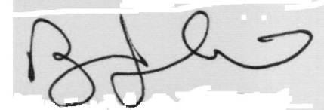


Very Truly Yours,

{{ATTORNEY_NAME}}, ESQ.
{{FIRM_NAME}}
AS/______

